Date: 27 /03/2025
Ref. No.: ICEM/Feb2025

One Page Report on “Celebration of Twinning Day”

Date: 13th February 2025
Venue: Avirat
Time: 3:00 PM

Brief Report:

Indira College of Engineering and Management, Pune, will celebrate Twinning Day on 13th February 2025. The event aims to promote creativity and unity among students, faculty, and staff. Participants will pair up as “twins” and showcase their coordinated outfits in a Ramp Walk Competition.

The competition will be judged on creativity, synchronization, and presentation. Prizes will be awarded in various categories, including “Most Creative Pair” and “Best Confidence.”

The event is expected to receive enthusiastic participation, offering students a chance to bond, express creativity, and build community spirit. Twinning Day promises to be a fun and memorable celebration, fostering unity and excitement across the campus.

Few Glimpses from the Event:

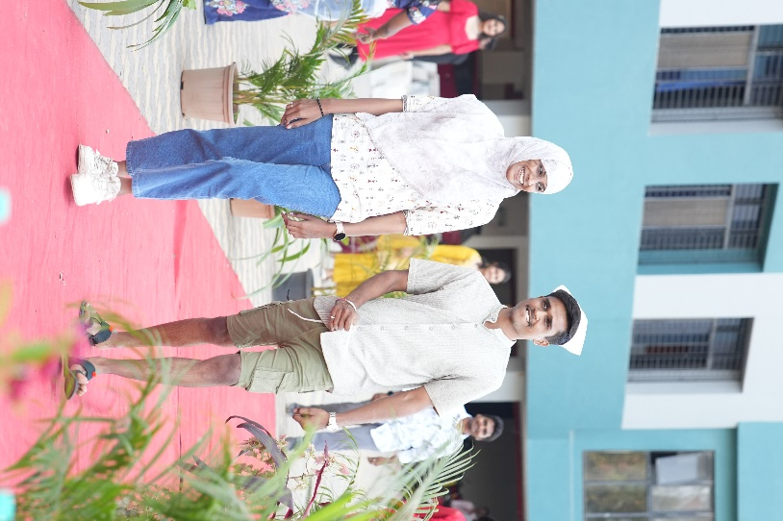
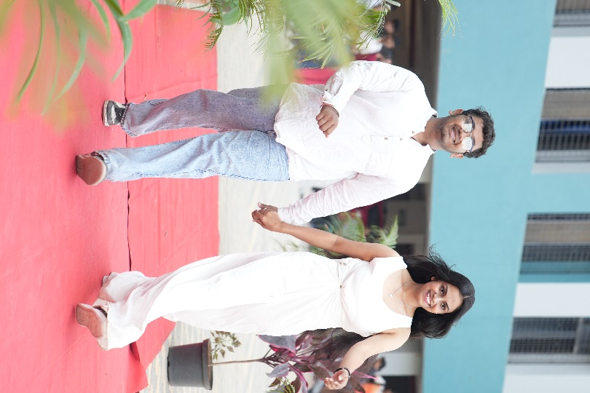

Preapred by: Submitted To:
Prof. Reshma Kohad Dr. Nilesh Uke
Cultural Coordinator I/C Principal

